Day 37

DIY

Problem Statement: Using AWS Lambda with Amazon Kinesis

Objective:

In this tutorial, you create a Lambda function to consume events from a

Kinesis stream.

1.Custom app writes records to the stream.

2.AWS Lambda polls the stream and, when it detects new records in the

stream, invokes your Lambda function

3.AWS Lambda runs the Lambda function by assuming the execution role you

specified at the Lambda function

Solution:

1. Create lambada function

-for that first create exexcution role

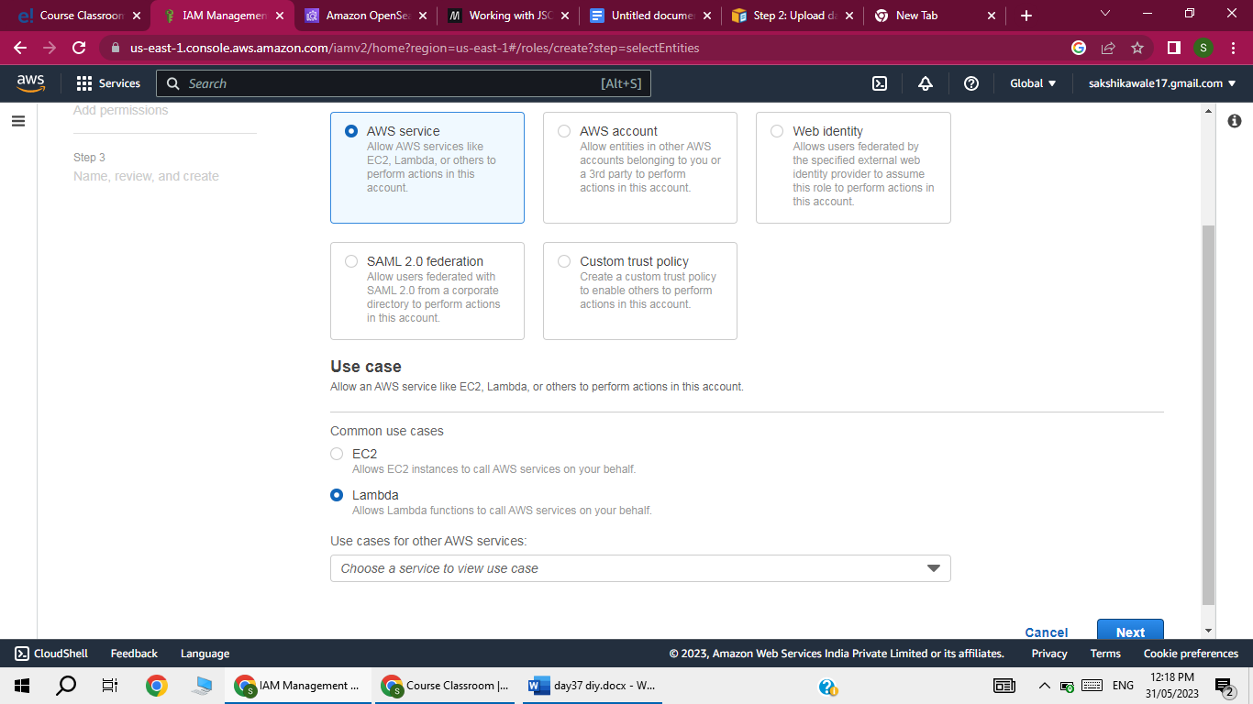

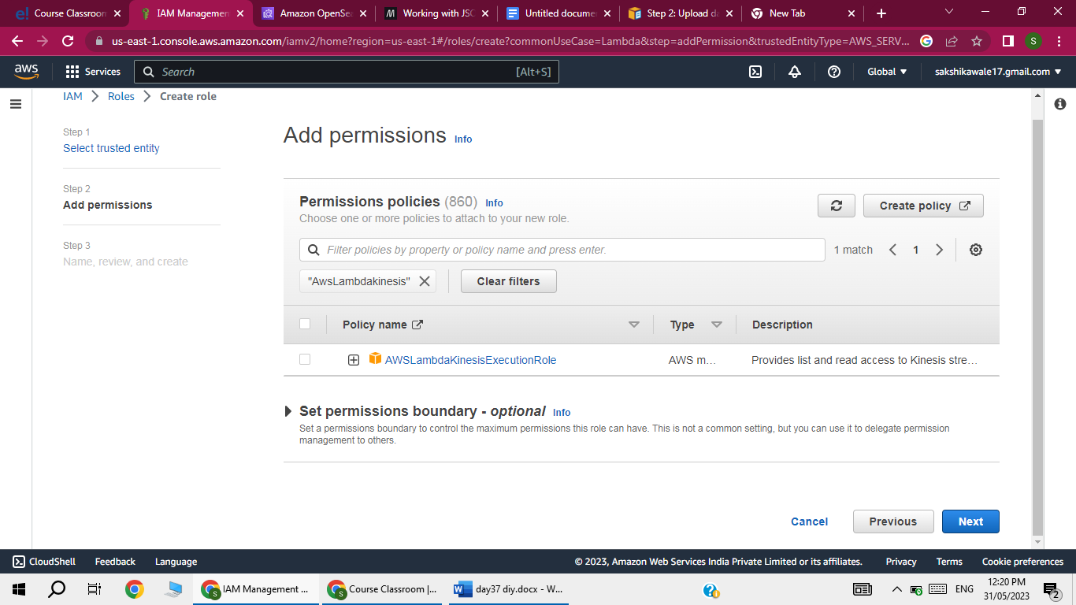

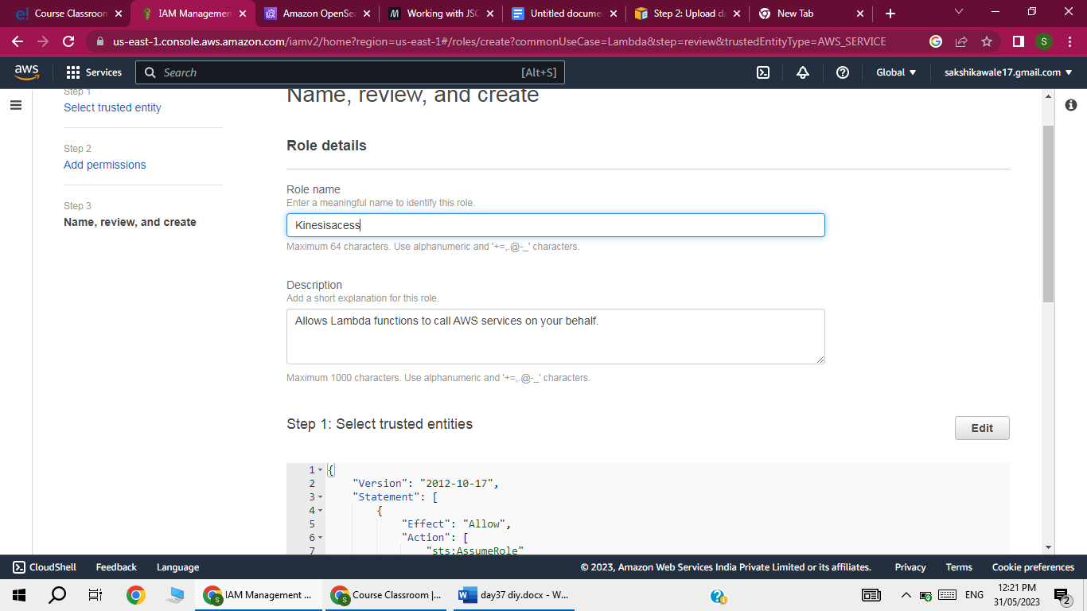

1. Now create lambda function

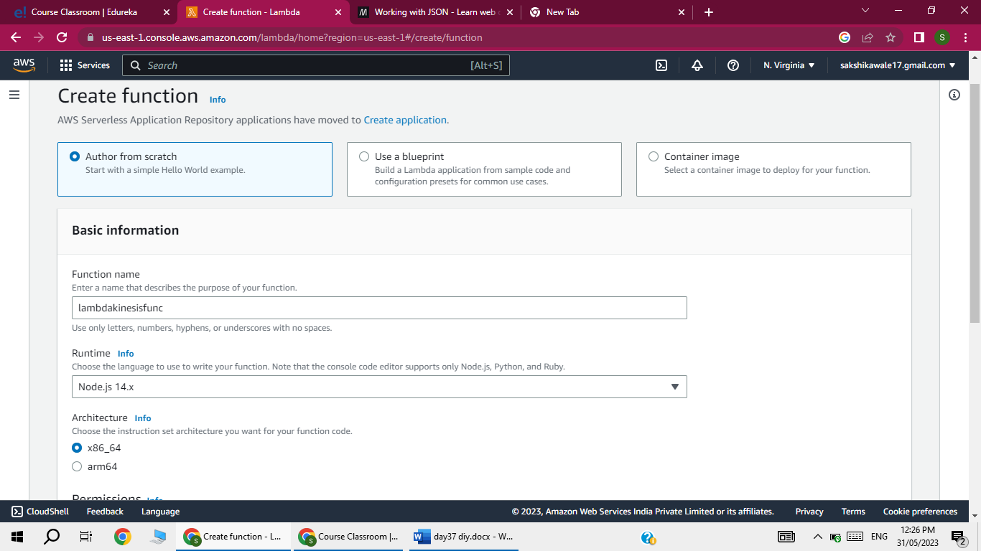

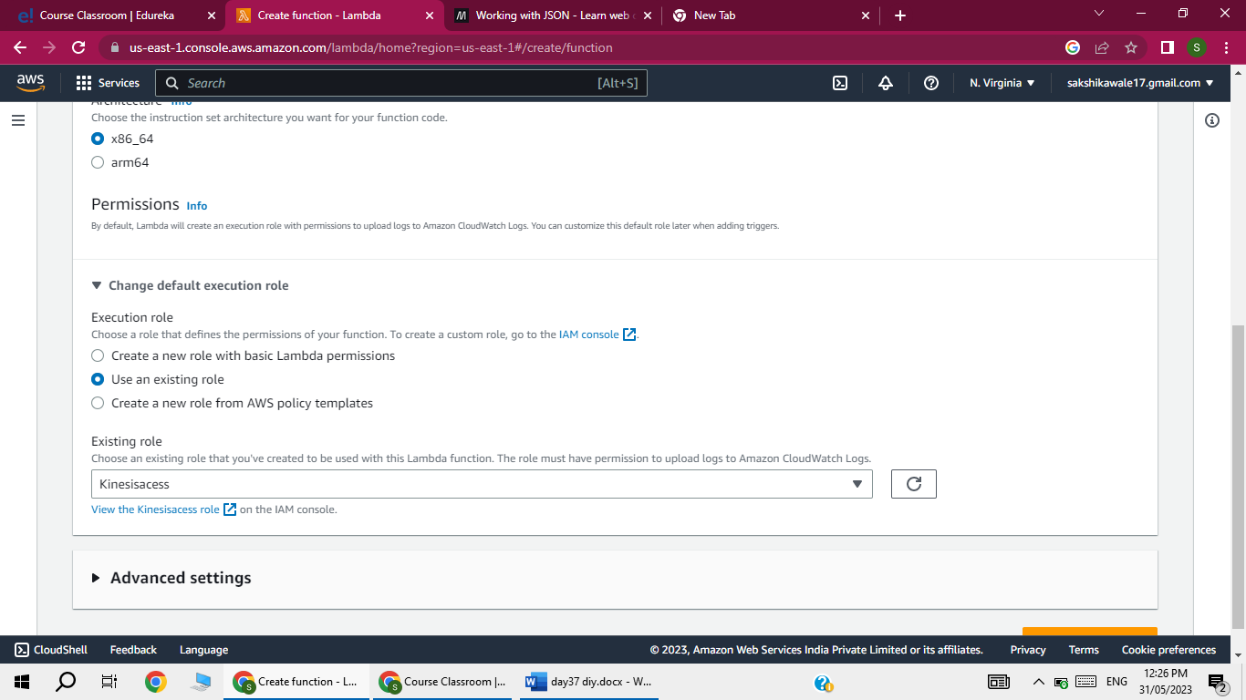

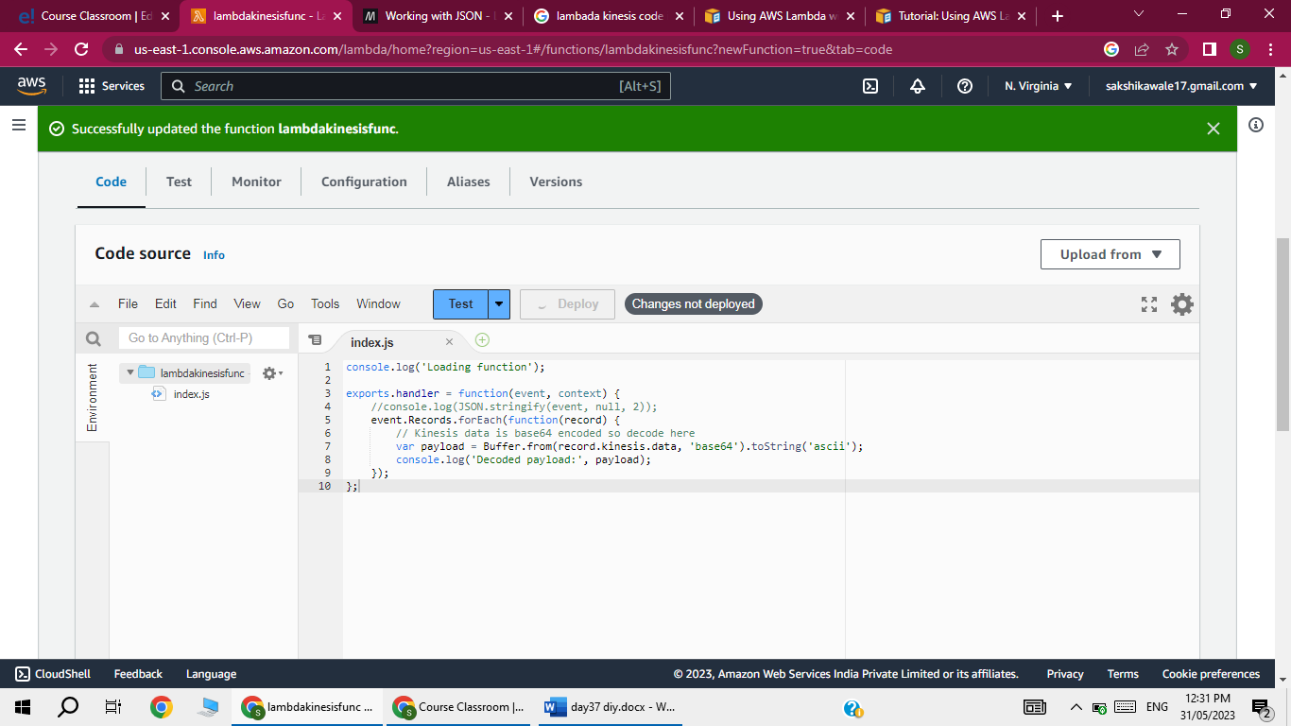

1. Create kinesis stream

